TellMyStory

The application allows the story writers to connect with publishers. The user can write the stories using available templates. He can select the category (such as horror, rom-com, fictional etc.) and post it. User will be able to see all the posts shared by other users along with the publisher name that it approved by. User can send request to any publisher, asking to publish his post in their newspaper or magazines. It is a role based login, where publisher can also see the requests sent to him. He can approve or reject the post.

# Application Scenario

After the registration/login, user will be able to see below tabs.

1. This application starts with login and register page.
2. Home -> On successful login user will be directed to Home page where he can all the published posts. User can filter the feeds based on the categories using the filter in the home page.
3. My profile -> It consists of basic details. It will be same for both user and publisher.
4. My posts -> for user It displays all the posts that is created by user. For Publisher It displays all the posts that are published or rejected by him.
5. New Blog -> this page will give a modal where user can request for publisher to publish his story.
6. Logout -> It will be same for both user and publisher.

# Instructions

* *A Project with the desired folder structure has been already created*. You are only permitted to alter the logical layer; creating files or folders is not permitted.
* The application includes a **database** layer and the required folders that contains the necessary code. You only need to complete the given objectives by writing your logic in the specified controller method.
* You are not allowed to directly insert new data into the database.
* Do not change any schema variables

# Backend Objectives

The application uses the APIs mentioned below. where some of the controllers and services have definitions and others have blank definitions, requiring you to develop logic to fulfil the objectives.

1. We have defined the below methods in the ***Controller*** Layer. You must complete the body of it.

@GetMapping("/getPost")

**public** ResponseEntity<ResponseDto> getMyPosts (@RequestParam Integer userId)

@PutMapping("/updateStatus")

**public** ResponseEntity<ResponseDto> updateStatus (@RequestParam Integer postId, @RequestParam String status)

1. We have defined below methods in ***Service*** Layer. You must complete the body of them.

List<NewPostDto> getPost (Integer userId)

Fetch all the posts which are uploaded in case of user. Fetch all the posts which are approved by him in case of publisher

NewPostDto updateStatus (Integer postId, String status)

Fetch the post by passing postId and update its status as specified

# Instructions

You are allowed to make changes only in below files.

1. TellMyStoryController.java

2. TellMyStoryServiceImple.java

You are not allowed to make any changes in below files.

1. application.properties
2. pom.xml

You are not allowed to make any changes in the files present in below packages.

1. com.example.tellmystory.constant

2. com.example.tellmystory.dto

3. com.example.tellmystory.entity

4. com.example.tellmystory.exception

5. com.example.tellmystory.handler

6. com.example.tellmystory.repository

# Build, Deploy and Run

1. Load the project in the IDE
2. Update the maven dependency
3. mvn life cycle to build & deploy
4. Run the project

### Frontend Objectives

**Instructions**

1. Implement the filter functionality in feed page to filter based on the categories selected by user.
2. the API response and store into respective data source variable which is used to render data in the pending, Approved and Rejected tabs.
3. Integrate postNewStory API to post new stories. Please refer to instructions section of API Details.

* You are allowed to make any changes to the below files.

1. Tell-my-story.component.html
2. Tell-my-story.component.ts.

# Build, Run and Deploy

* + Load the project in VS Code.
  + Install the packages.
  + You can use the build command and deploy the application on the server.
  + Start the development server.

**User Interface Designs**

* Register and Login page will look as below

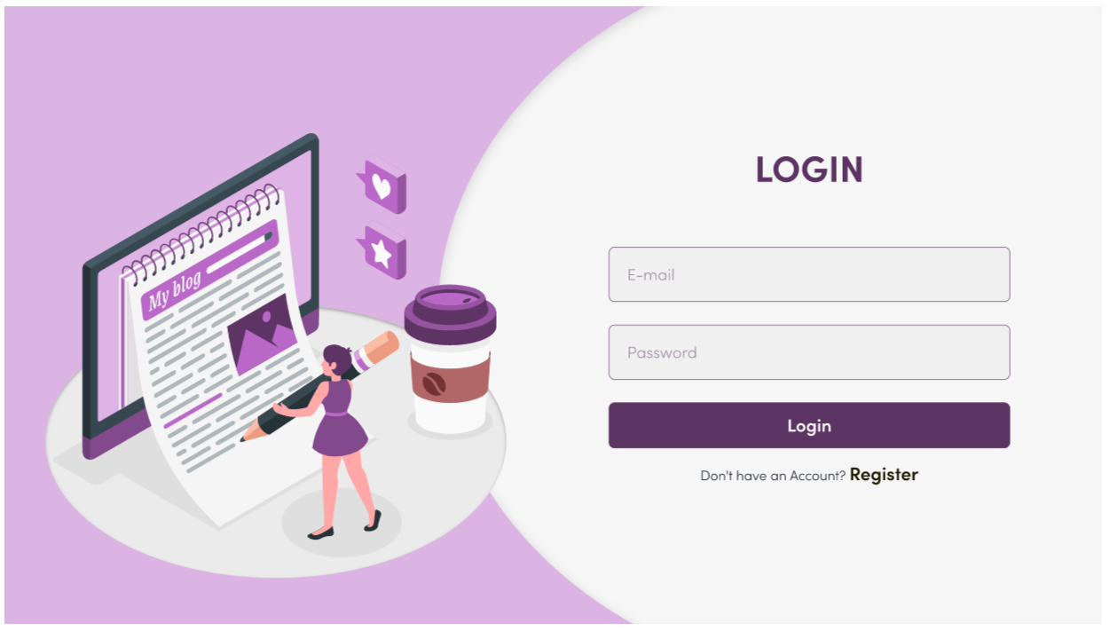

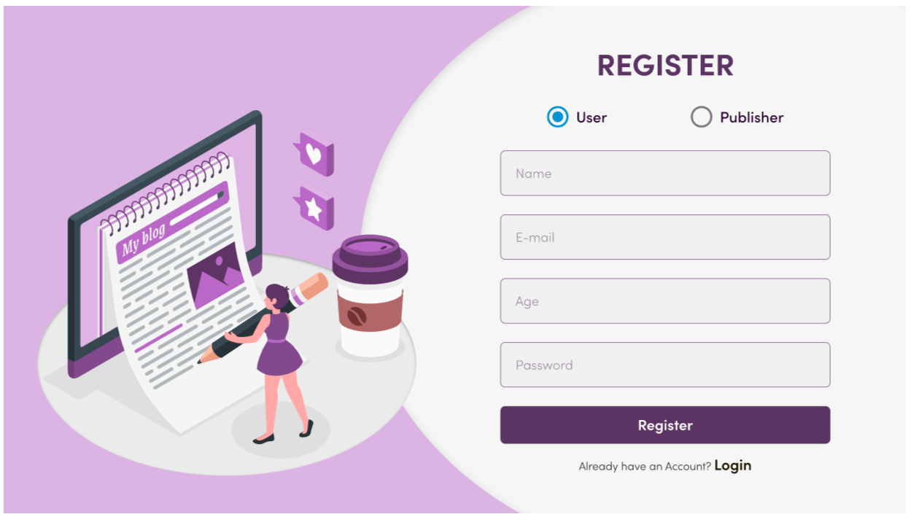

* Home Page will look as below

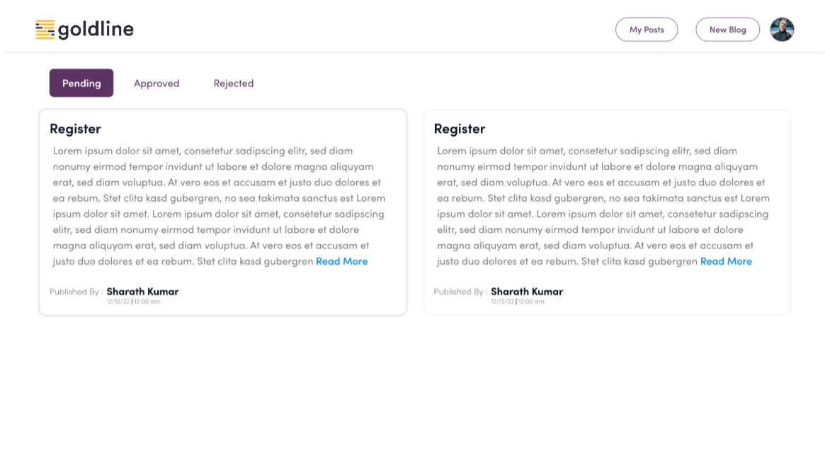

* When click on read more below modal will be opened to Display full story

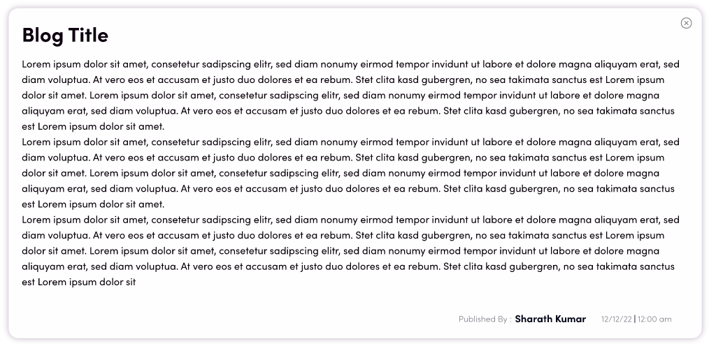

* Post new Story modal will look as shown below

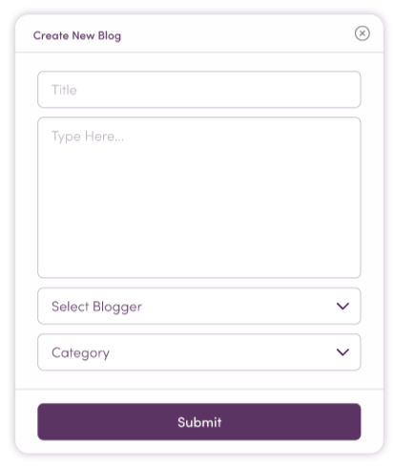

* My Profile Page will look as below

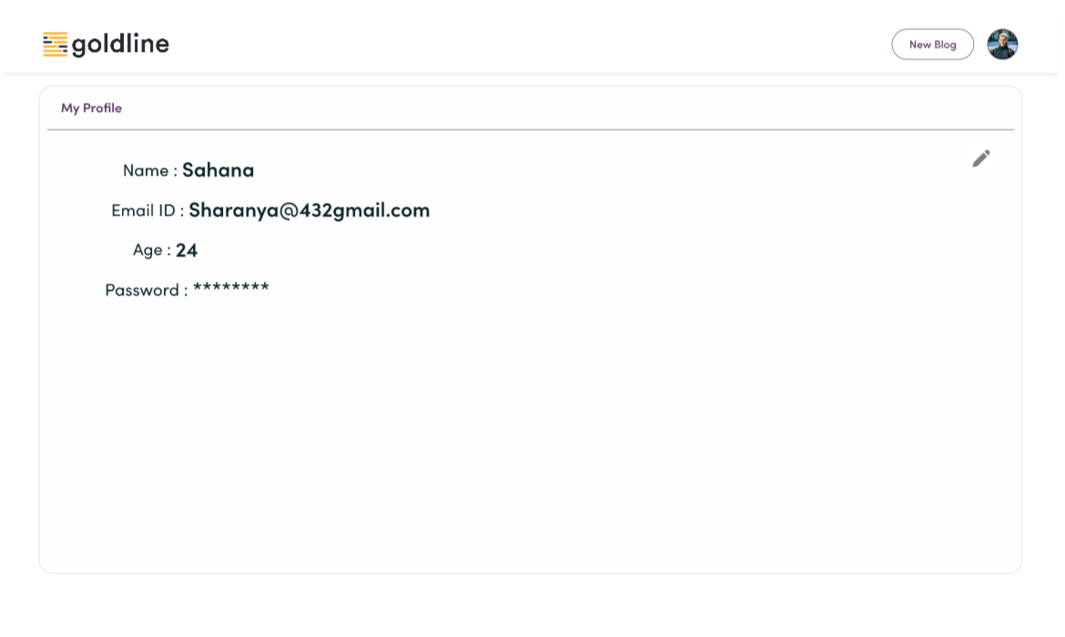

* Approved, Pending, Requests and Rejected tabs will look as below

